Task Eight
语篇形式主要指消息报道，特写文章和新闻评论三种形式。

社会新闻social news

社会新闻是具有社会教育意义的新闻报道，以其特有的言行举止、境遇打动人、感染影响人，使人从这些新闻中感受到某种道德观、价值观或者世界观。

Key Learning points:
Try to locate the following sentences in the text materials(page 124-130) and give your understanding about them(注意句子结构成分的分布特征及句意的表达特点)
- Like many up-and-coming nations, Vietnam has been using beauty contests to quickly make its mark on the world.
- But that pride crumbled after government investigators found that the new Miss Vietnam , crowned on Aug.31, hadn’t finished high school.
- In an interview in her hometown of Danang , in the center of Vietnam’s long, snaking coastline, Ms. Thy Dung tried to shake off her disappointment at staying behind. “I wish Vietnam can still find the right candidate to send to Miss World, even if it isn’t me,” she said.
- The annual Miss Vietnam pageant is fiercely contested, despite the contestants’ avowals that they are all sisters hoping to do the country proud.
- The stakes have risen since then. Winners of the Miss Vietnam pageant have won scholarships to study overseas.
- The nation was shocked, and badly divided, when news broke that Ms. Thuy Dung had dropped out of high school.
- On Friday morning, Nate gulped silently as Judge Richard Wennet finally determined his fate:Instead of life imprisonment, Nate will serve 28 years, followed by another seven years of house arrest and probation.
- Still, the question remains whether the seventh-grader deserved more or less. The judge may have ordered him to get his high schooling and take anger-management courses in prison, but can Nate return to normal life after growing up inside?
- In an interview with TIME before the jury convicted him in May, Nate said he did not intend to pull the trigger. It just happened.

The first article
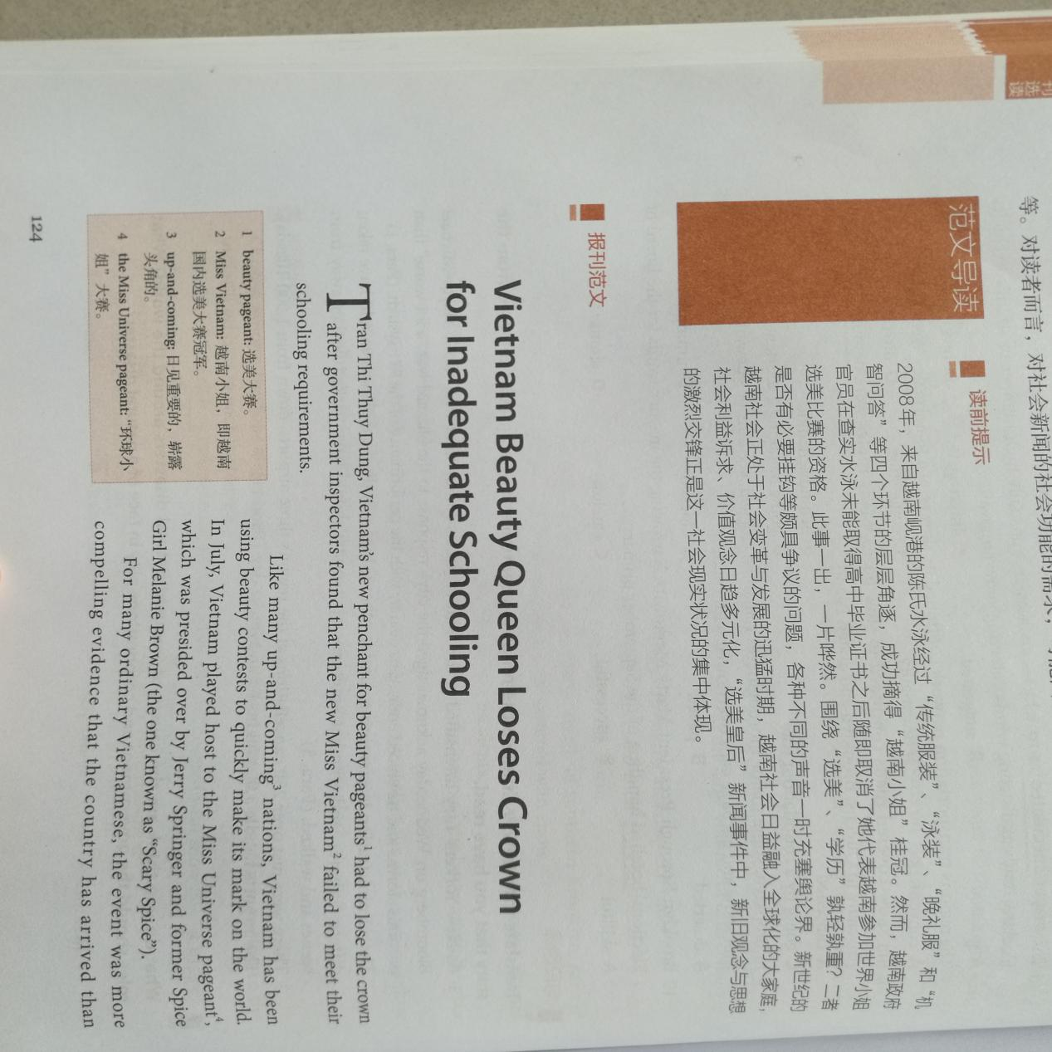

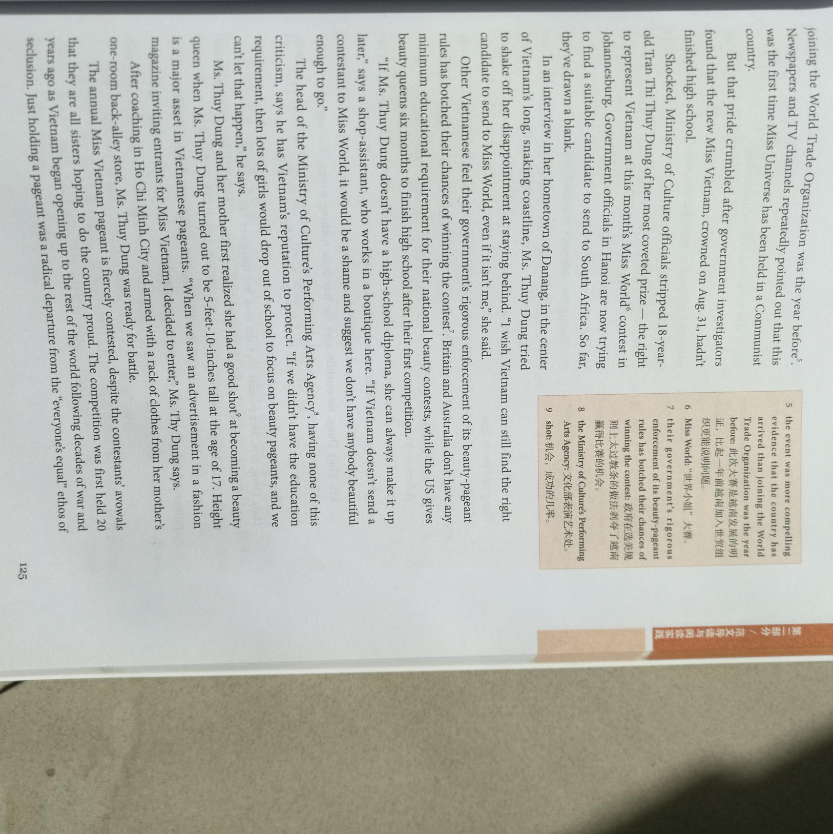

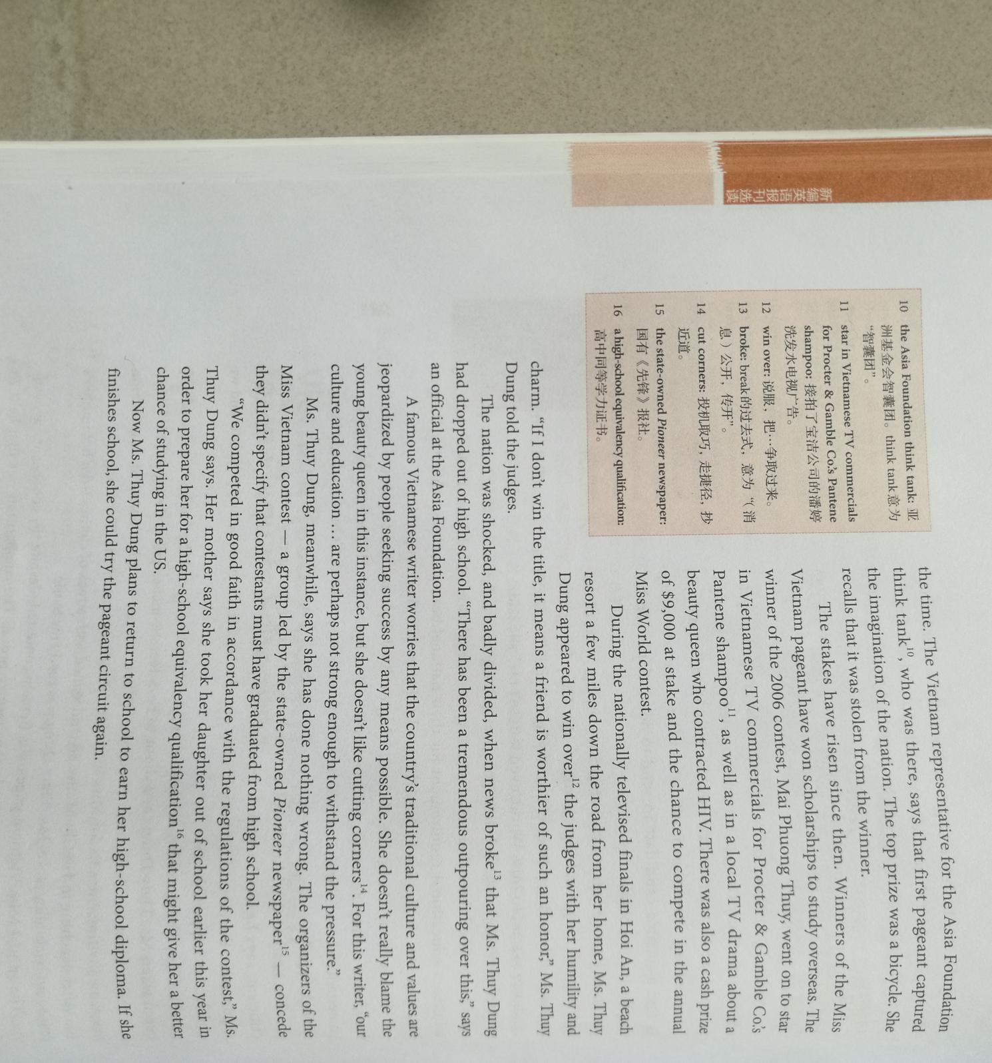

The second article
